**ShopDeck, E-Commerce Web Application**

A Project-II Report

Submitted in partial fulfillment of requirement of the

Degree of

**BACHELOR OF TECHNOLOGY in COMPUTER SCIENCE & ENGINEERING**

BY

**Naman Gupta**

**EN18CS301154**

Under the Guidance of

**Dr. Kailash Chandra Bandhu**

**Mr. Binod K Mishra**



**Department of Computer Science & Engineering**

**Faculty of Engineering**

**MEDI-CAPS UNIVERSITY, INDORE- 453331**

**January 2022 - May 2022**

**ShopDeck, E-Commerce Web Application**

A Project-II Report

Submitted in partial fulfillment of requirement of the

Degree of

**BACHELOR OF TECHNOLOGY in COMPUTER SCIENCE & ENGINEERING**

BY

**Naman Gupta**

**EN18CS301154**

Under the Guidance of

**Dr. Kailash Chandra Bandhu**

**Mr. Binod K Mishra**



**Department of Computer Science & Engineering**

**Faculty of Engineering**

**MEDI-CAPS UNIVERSITY, INDORE- 453331**

**January 2022 – May 2022**

**Report Approval**

The project work **“ShopDeck, E-Commerce Web Application”** is hereby approved as a creditable study of an engineering/computer application subject carried out and presented in a manner satisfactory to warrant its acceptance as prerequisite for the Degree for which it has been submitted.

It is to be understood that by this approval the undersigned do not endorse or approved any statement made, opinion expressed, or conclusion drawn there in; but approve the “Project Report” only for the purpose for which it has been submitted.

Internal Examiner

Name:

Designation

Affiliation

External Examiner

Name:

Designation

Affiliation

**Declaration**

I hereby declare that the project entitled **“ShopDeck, E-Commerce Web Application”** submittedin partial fulfillment for the award of the degree of Bachelor of Technology in ‘Computer Science’ completed under the supervision of **Dr. Kailash Chandra Bandhu,** Associate Professor, Computer Science and Engineering**,** Faculty of Engineering, Medi-Caps University Indore and **Mr. Amir Sohel, Tata Consultancy Services** is an authentic work.

Further, I declare that the content of this Project work, in full or in parts, have neither been taken from any other source nor have been submitted to any other Institute or University for the award of any degree or diploma.

**Signature and Name of the Student with Date**

**Certificate**

We, **Dr. Kailash Chandra Bandhu and Mr. Amir Sohel** certify that the project entitled **“ShopDeck, E-Commerce Web Application”** submittedin partial fulfillment for the award of the degree of Bachelor of Technology by **Naman Gupta** istherecordcarried out by him under our guidance and that the work has not formed the basis of award of any other degree elsewhere.

________________________________

Dr. Kailash Chandra Bandhu

Computer Science & Engineering

Medi-Caps University, Indore

Mr. Amir Sohel

Tata Consultancy Services

_____________________

Dr. Pramod S. Nair

Head of the Department

Computer Science & Engineering

Medi-Caps University, Indore

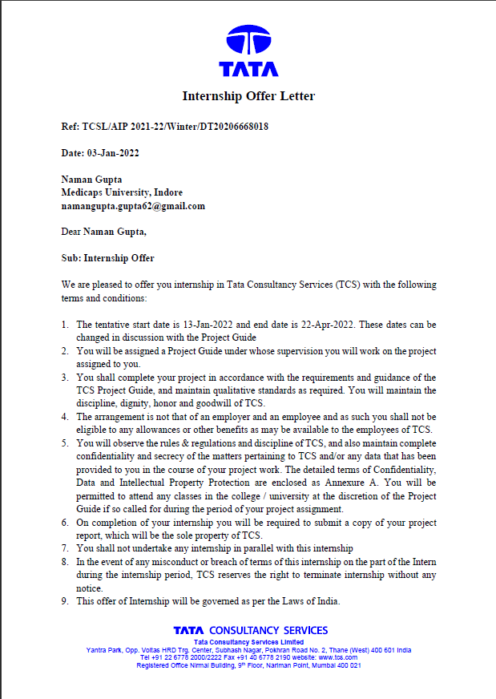**Offer Letter of the Project Work-II/Internship**

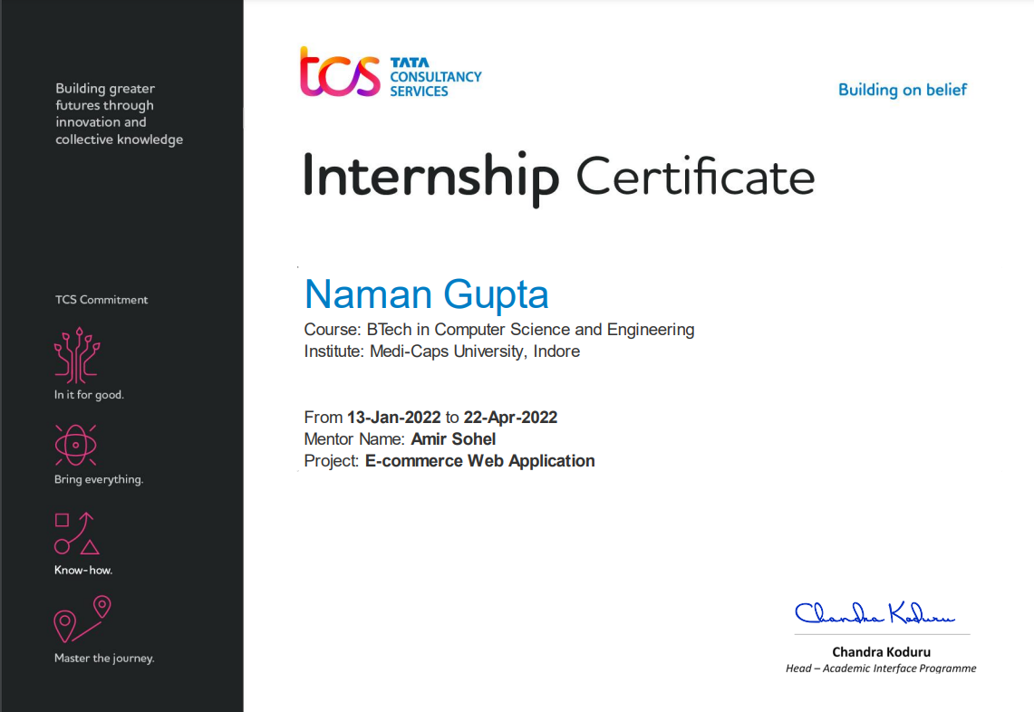**Completion Certificate/Letter**

**Acknowledgement**

I would like to express my deepest gratitude to Honorable Chancellor, **Shri R C Mittal,** who has provided me with every facility to successfully carry out this project, and my profound indebtedness to **Prof. (Dr.) Dilip K Patnaik,** Vice Chancellor, Medi-Caps University, whose unfailing support and enthusiasm has always boosted up my morale. I also thank **Prof. (Dr.) D K Panda,** Pro Vice Chancellor, **Dr. Suresh Jain,** DeanFaculty of Engineering, Medi-Caps University, for giving me a chance to work on this project. I would also like to thank my Head of the Department **Dr. Pramod S. Nair** for his continuous encouragement for betterment of the project.

I express my heartfelt gratitude to my **External Guide, Mr. Amir Sohel**, Project Lead, Tata Consultancy Services Ltd as well as to my Internal Guide, Dr. Kailash Chandra Bandhu**,** Associate Professor, Department of Computer Science Engineering, MU, without whose continuous help and support, this project would ever have reached to the completion.

I would also like to thank to my team at TCS Mr. Prafull Tiwari, Ms. Pranjal Chaturvedi who extended their kind support and help towards the completion of this project. It is their help and support, due to which we became able to complete the design and technical report. Without their support this report would not have been possible.

**Naman Gupta**

B.Tech. IV Year

Department of Computer Science & Engineering

Faculty of Engineering

Medi-Caps University, Indore

**Executive Summary**

**Objective**

As a part of my under-graduate program, I joined Tata Consultancy Services on 13 January 2022 as an intern. The objective is to learn technologies and applications and implement them to achieve an industry ready web application. The name of our web application is "SHOPECK". The domain on which we will be working is web development. We will be making an E-Commerce web application. Project is being built using React JS as the front-end language. The web application is responsive and looks good on all standard screen sizes.

**Requirement**

The following technical assets will be required:

* React JS: Easy to use framework to make user friendly web applications
* CSS: CSS is a design language that makes a website look more appealing
* JavaScript: a text-based programming language used both on the client-side and server-side that allows you to make web pages interactive.
* Visual studio code:  a code editor redefined and optimized for building and debugging modern web and cloud applications.
* Git: a free and open-source distributed version control system designed to handle everything from small to very large projects.

**Table of Contents**

|  |  |  |
| --- | --- | --- |
| **Chapter No.** | **Chapter Titles** | **Page No.** |
|  | Report Approval | ii |
|  | Declaration | iii |
|  | Certificate | iv |
|  | Offer Letter of the Project work-II/Internship | v |
|  | Completion letter/certificate | vi |
|  | Acknowledgement | vii |
|  | Abstract | viii |
|  | Table of Contents | ix |
|  | List of figures | xi |
|  | Abbreviations | xii |
| Chapter 1 | Introduction |  |
|  | 1.1 Introduction | 1 |
|  | 1.2 Objectives | 2 |
|  | 1.3 Scope | 2 |
|  | 1.4 Organization Details | 3 |
| Chapter 2 | Project Details |  |
|  | 2.1 Project Introduction | 4 |
|  | 2.2 Domain | 4 |
|  | 2.3 Software Requirement | 5 |
|  | 2.4 System Analysis | 5 |
|  | 2.4.1 Hardware and Software Requirements | 6 |
|  | 2.4.2 Feasibility Study | 6 |
|  | 2.4.3 Non Functional Requirements | 7 |
|  | 2.4 Intended Audience | 8 |
|  | 2.5 Advantages | 8 |
| Chapter 3 | Project Setup |  |
|  | 3.1 NodeJS | 9 |
|  | 3.2 ReactJS | 11 |
|  | 3.3 Firebase | 12 |
|  | 3.4 GitHub | 13 |
|  | 3.5 Visual Studio Code | 13 |
| Chapter 4 | Technology Description |  |
|  | 4.1 NodeJS | 14 |
|  | 4.2 ReactJS | 17 |
|  | 4.3 JavaScript | 20 |
|  | 4.4 CSS | 23 |
|  | 4.5 Git | 24 |
| Chapter 5 | System and Designing |  |
|  | 5.1 Use Case Diagram | 26 |
|  | 5.2 State Chart Diagram | 27 |
| Chapter 6 | Project Screenshots |  |
|  | 6.1 Login Page | 28 |
|  | 6.2 Sign-Up Page | 29 |
|  | 6.3 Home Page | 30 |
|  | 6.4 Home Page Categories | 31 |
|  | 6.5 Product Details | 32 |
|  | 6.5 Catalog | 33 |
|  | 6.6 Cart | 34 |
|  | 6.7 Payment Page | 35 |
|  | 6.8 Checkout Page | 36 |
| Chapter 7 | Result and Discussion | 37 |
| Chapter 8 | Summary and Conclusions | 38 |
| Chapter 9 | Future scope | 39 |
|  | Bibliography | 40s |

**List of Figures**

|  |  |  |
| --- | --- | --- |
| Figure No. | Figure Title | Page No. |
| Figure 3.1 | Node JS Website | 9 |
| Figure 3.2 | Node JS Setup | 10 |
| Figure 3.3 | Command Prompt | 11 |
| Figure 4.1 | Node JS Properties | 14 |
| Figure 4.2 | Node JS Concepts | 16 |
| Figure 4.3 | React Properties | 17 |
| Figure 4.4 | JSX Characteristics | 18 |
| Figure 4.5 | DOM Diagram | 19 |
| Figure 4.6 | Features of JavaScript | 21 |
| Figure 5.1 | Use Case Diagram | 26 |
| Figure 5.2 | State Chart Diagram | 27 |
| Figure 6.1 | Login Page | 28 |
| Figure 6.2 | Sign-Up Page | 29 |
| Figure 6.3 | Home Page | 30 |
| Figure 6.4 | Home Page Categories | 31 |
| Figure 6.5 | Product Details | 32 |
| Figure 6.6 | Catalog | 33 |
| Figure 6.7 | Cart | 34 |
| Figure 6.8 | Payment Page | 35 |
| Figure 6.9 | Checkout Page | 36 |

**Abbreviations**

ECS - E-commerce System

SRS - Software Requirements Specification

URL - Uniform Resource Locator

UI - User Interface

DOM - Document Object Model

APN - Access Point Name

OTP - One Time Password/PIN

**Chapter-1**

* 1. **Introduction**

An E-commerce website requires appropriate strategy of successful design and implementation. Everything is required to plan from scratch to end of website. The e-commerce sector is seen the exponential growth thus a new option will easily part of this regatta of commercial website. The e-commerce website will feature the online shopping facility of various fashion products under a single web space. The proposed web application will allow business personnel to make their total business using it and increase their reachability thousands of times more than today they have, over the internet. It will allow multiple shopping vendors to sale their products online. The product management in the system will be done in the form of categories. The safety of information is the main requirement of the system and will be handling according to that. To formulate this project first task is to do is cost estimation. For probabilistic assessment of the project cost estimation is required. Cost estimation covers the accurate; estimations of cost and effort required for the project. As a project manager and developer as well, it’s is estimates are defined to early stage in the project. Cost estimation in application development project includes the set of procedures and techniques that will be utilized, required to produce by organization for development (Alex,2013). The available resources of a company are also affecting the cost estimation. It will be very complex project. To demonstrate knowledge learnt in class, tech communities and online materials, I will undertake the entire project alone even though it requires a team of 6 or more. It will take time of 3months to get the shape or get the basic structure. The environment variants depend on the further requirements of the ecommerce web application.

Customer get many benefits via online shopping this helps e-commerce companies to build long-lasting and profitable relationship with their customers. For making strong relationship with these users, it is very important to focus on the customer as a whole and making sense of a flood of real-time information that goes well beyond demographics or shopping behavior. There are two entities who will have the access to the system. One is the admin and another one will be the registered user. Admin can add product details, view all the order details and can also view the sales of the products. User need to register with basic registration details to generate a valid username and password. After the user logins, it can view all the products that are recommended on the homepage compiled by the system based on user’s information. From the recommended products, the user can even further view its details and then if interested to buy, the system gives add to cart option for purchasing the product. The system even has an AI bot with the help of which the user can get answers to queries like features, warranty, price etc. details of the products. This AI Bot even converts text to speech. After selecting the product, user can do payment for the particular product online. Users can view their order history of their purchased product.

* 1. **Objective**

Defining and describing the functions and specifications of the E-Commerce System (ECS) is the primary goal of this Software Requirements Specification (SRS). This Software Requirements Specification illustrates, in clear terms, the system’s primary uses and required functionality as specified by our customer.

The main aim of e-commerce websites development is to sell products to users. The most successful websites are carefully optimized to achieve a high percentage of purchases. To achieve success e-commerce websites, need to integrate all of the latest online closing & upsell techniques available which have been proven to increase the chances that a visitor will purchase. There are many important elements that go into building a successful e-commerce website such as removing friction during the purchasing process, making the checkout smooth and easy, making the website fast and attractive, up selling users on related products, incentivizing buyers, reducing cart abandonment, nurturing past buyers to buy again, remarketing to past visitors who haven’t yet purchased, using the proper payment options, having a mobile ready design and many more things which are needed to develop and e-commerce website.

* 1. **Scope**
* Primarily, the scope pertains to the E-Store product features for making E-commerce App project live. It focuses on the company, the stakeholders and applications, which allow for online sales, distribution and marketing of products.
* This E-Commerce App will allow any user to create an account to become a customer. The customer, through the process of account creation, will have the option to become a member of the site. The system will allow customers to browse, search, select, and add products to a shopping cart. Then, provided they have products (i.e., jackets/shoes/jeans etc.) in their shopping cart, check out products in shopping cart and add their address where product will be delivered then make the Payment.
  1. **Organization Details**

Tata Consultancy Services is an Indian multinational information technology services and consulting company headquartered in Mumbai, Maharashtra, India with its largest campus located in Chennai, Tamil Nadu, India. As of February 2021, TCS is the largest IT services company in the world by market capitalization. It is a subsidiary of the Tata Group and operates in 149 locations across 46 countries.

My Profile at Tata Consultancy Services during this internship period is project intern. I have been training to work on various concepts that will be required in my project. Goal is to learn technologies and applications and implement them to achieve an industry ready web application. Project is being built using React JS as the front-end language.

**Chapter-2**

**2.1 Project Introduction**

The domain on which we will be working is web development. We will be making an E-Commerce web application. The name of our web application is "SHOPECK". Goal is to learn technologies and applications and implement them to achieve an industry ready web application.

Project is being built using React JS as the front-end language. The web application is responsive and looks good on all standard screen sizes (for e.g., desktop, laptop, tablet and mobile). The unique design which the website provides enhances user experience of the application.

The following features are provided in our E-Commerce web application:

* Sign up and login screen for registration / authentication of user.
* Home screen with grid list of products.
* Search bar to search content.
* Categories option to view products category wise.
* Details screen with detail of a particular product, add to cart and order now options.
* Payment screen and order successful screen after checkout.
* Profile screen for user details and edit profile.
* Sign out option.

**2.2 Domain**

Web development, also known as website development, refers to the tasks associated with creating, building, and maintaining websites and web applications that run online on a browser. It may, however, also include web design, web programming, and database management. Web development is closely related to the job of designing the features and functionality of apps (web design). The term development is usually reserved for the actual construction of these things (that is to say, the programming of sites). The basic tools involved are programming languages called HTML (Hypertext Markup Language), CSS (Cascading Style Sheets), and JavaScript. There are, however, a number of other programs used to “manage” or facilitate the construction of sites that would otherwise have to be done “from scratch” by writing code.

**2.3 Software Requirement**

The following technical assets will be required:

* React JS: Easy to use framework to make user friendly web applications
* HTML: a coding language used to create pages that a web browser can display.
* CSS: CSS is a design language that makes a website look more appealing
* JavaScript: a text-based programming language used both on the client-side and server-side that allows you to make web pages interactive.
* Firebase: a platform developed by Google for creating mobile and web applications.
* Visual studio code: a code editor redefined and optimized for building and debugging modern web and cloud applications.
* Git: a free and open-source distributed version control system designed to handle everything from small to very large projects.

**2.4 System Analysis**

Systems analysis is the process by which an individual studies a system such that an information system can be analyzed, modeled, and a logical alternative can be chosen. Systems analysis projects are initiated for three reasons: problems, opportunities, and directives. The people involved include systems analysts, sponsors, and users. The process by which systems are developed can be described by the systems development life cycle.

**2.4.1 Hardware and Software Requirement**

For Web Hardware Requirement is not much in ShopDeck but due to the browser compatibility these were the minimum configuration you must have but as TCS provide asset to all their employees which much more specification running ShopDeck is really very simple and easy

|  |  |
| --- | --- |
| Device’s Components | Specification |
| Processor | Intel i3 or Higher |
| RAM | Minimum 4 GB |
| Space Required | Less than 100 MB |

Table 1: Hardware Requirement

**2.4.2 Feasibility Study**

Feasibility study includes consideration of all the possible ways to provide a solution to the given problem. The proposed solution should satisfy all the user requirements and should be flexible enough so that future changes can be easily done based on the future upcoming requirements.

**2.4.2.1 Economical Feasibility**

This is a very important aspect to be considered while developing a project.

We decided the technology based on minimum possible cost factor-

1. All hardware and software cost has to be borne by the organization.
2. Overall, we have estimated that the benefits the organization is going to receive from the proposed system will surely overcome the initial costs and the later on running cost for system.

**2.2.4.2 Technical Feasibility**

This included the study of function, performance and constraints that may affect the ability to achieve an acceptable system. For this feasibility study, we studied complete functionality to be provided in the system, as described in the System Requirement Specification (SRS), and checked if everything was possible using different type of frontend and backend platforms.

**2.4.2.3 Behavioral Feasibility**

No doubt the proposed system is a fully real time-based application and we had used GUI also i.e. very user friendly. Besides, proper training has been conducted to let them know the essence of the system so that they feel comfortable with the new system. As far as our study is concerned the clients are comfortable and happy as the system has cut down their loads and doing.

**2.4.3 Non-Functional Requirement**

Non-functional requirements specify criteria that can be used to judge the operation of a system in particular. These are conditions rather than specific behaviors. While functional requirements define what a system is supposed to do, non-functional requirements define how a system is supposed to be. Non-functional requirements are often called ''quality attributes'' of a system.

Examples for ShopDeck may include:

* Performance - how much time each page should take to load
* Scalability - will the system be able to handle large volume of users that keeps increasing?
* Capacity - how much storage will be needed?
* Availability - availability and downtime of the application
* Security - this includes security of the content and encryption

**2.5 Intended Audience**

The success of an E Commerce store highly depends on the traffic you’re generating on your website. More important to that, the traffic that you’re getting has to be potential enough that brings sales and conversions.

Our intended audience is a group of people or institutions that are most likely to share the same shopping interests and might be willing to buy a company’s products and services. Online shopping is mainly used by older people who are working as they have a credit card from which they can pay for their goods. Young people do use the service of online shopping to buy things such as clothes and games as it is of greater convenience to them.

**2.6 Advantages**

* Can be done in the comfort of your own home
* Gain new customers with search engine visibility
* Eliminate time travel and cost
* Remain open all time
* Create market for niche products
* Remain open all the time
* Create targeted communications

**Chapter-3**

**3.1 NodeJS**

Node.js is an open-source, cross-platform, back-end JavaScript runtime environment that runs on the V8 engine and executes JavaScript code outside a web browser.

Node. js is primarily used for non-blocking, event-driven servers, due to its single-threaded nature. It's used for traditional web sites and back-end API services, but was designed with real-time, push-based architectures in mind.

**Installation Steps**

1. Download Node.js from the official Node.js web site: <https://nodejs.org>

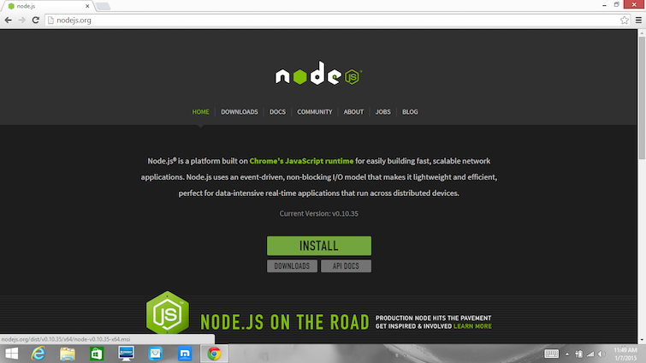

1. Run the installer (the .msi file you downloaded in the previous step.)
2. 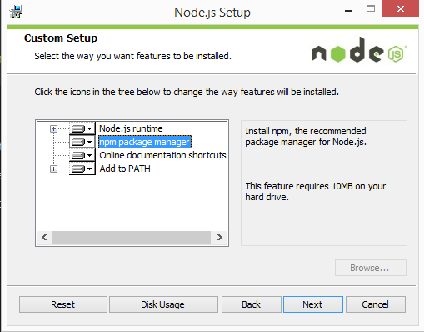Follow the prompts in the installer (Accept the license agreement, click the NEXT button a bunch of times and accept the default installation settings).
3. Restart your computer. You won’t be able to run Node.js until you restart your computer.

**Testing:**

Make sure you have Node and NPM installed by running simple commands to see what version of each is installed:

* Test Node. To see if Node is installed, open the Windows Command Prompt, PowerShell or a similar command line tool, and type node -v. This should print the version number so you’ll see something like this v0.10.35.
* Test NPM. To see if NPM is installed, type npm -v in Terminal. This should print the version number so you’ll see something like this 1.4.28
* Create a test file and run it. A simple way to test that node.js works is to create a simple JavaScript file: name it hello.js, and just add the code console.log ('Node is installed!'). To run the code simply open your command line program, navigate to the folder where you save the file and type node hello.js. This will start Node.js and run the code in the hello.js file. You should see the output Node is installed.

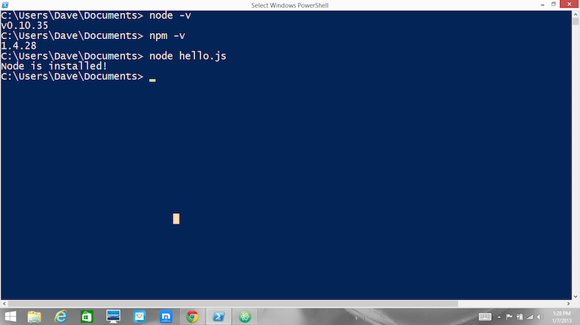

**3.2 ReactJS**

React is a way to build user interfaces. It is only concerned with what you see on the front-end. React makes user interfaces very easy to build by cutting each page into pieces. We call these pieces components.

**React Application Setup:**

Create react app

1. Open a terminal (Windows Command Prompt or PowerShell).
2. Create a new project folder: mkdir React Projects and enter that directory: cd React Projects.
3. Install React using create-react-app, a tool that installs all of the dependencies to build and run a full React.js application:

npx create-react-app my-app

1. This will first ask for your permission to temporarily install create-react-app and its associated packages. Once completed, change directories into your new app ("my-app" or whatever you've chosen to call it):

cd my-app.

1. Start your new React app: npm start

**3.3 Firebase**

Firebase is a mobile and web app development platform that provides developers with a plethora of tools and services to help them develop high-quality apps, grow their user base, and earn more profit.

**Firebase UI Authentication Method:**

Firebase UI Authentication is a way to add a complete sign-in system to our app, where Firebase provides user interface to them. Firebase UI provides a drop-in auth solution which is used to implement authentication on mobile devices and websites.

There are the following steps to use Firebase UI Authentication:

* Set up sign-in methods:
* Enable authentication method in the firebase console.
* For email address and password, phone number sign-in, and any identity providers.
* We have to complete the configuration if anyone requires for identity providers.
* Setting our OAuth redirect URL.
* Customize the sign-in UI.
* For customizing the sign-in and UI, we have to set some Firebase UI options or fork the code on GitHub.
* To perform the sign-in flow, use Firebase UI:
* Import the Firebase UI library.
* Specify the sign-in method which we want to support.
* Initiate the Firebase UI sign-in flow.

**3.4 GitHub**

GitHub is an increasingly popular programming resource used for code sharing. It's a social networking site for programmers that many companies and organizations use to facilitate project management and collaboration. GitHub is a highly used software that is typically used for version control. It is helpful when more than just one person is working on a project. Say for example, a software developer team wants to build a website and everyone has to update their codes simultaneously while working on the project. In this case, GitHub helps them to build a centralized repository where everyone can upload, edit, and manage the code files.

**3.5 Visual Studio Code**

Visual Studio Code, also commonly referred to as VS Code, is a source-code editor made by Microsoft for Windows, Linux and macOS. Features include support for debugging, syntax highlighting, intelligent code completion, snippets, code refactoring, and embedded Git. Users can change the theme, keyboard shortcuts, preferences, and install extensions that add additional functionality.

Instead of a project system, it allows users to open one or more directories, which can then be saved in workspaces for future reuse. This allows it to operate as a language-agnostic code editor for any language. It supports many programming languages and a set of features that differs per language. Unwanted files and folders can be excluded from the project tree via the settings.

**Chapter-4**

**4.1 NodeJS**

Node.js is a very powerful JavaScript-based platform built on Google Chrome's JavaScript V8 Engine. It is used to develop I/O intensive web applications like video streaming sites, single-page applications, and other web applications. Node.js is open source, completely free, and used by thousands of developers around the world.

Node.js is a server-side platform built on Google Chrome's JavaScript Engine (V8 Engine). Node.js was developed by Ryan Dahl in 2009 and its latest version is v0.10.36. The definition of Node.js as supplied by its official documentation is as follows –

*Node.js is a platform built on Chrome's JavaScript runtime for easily building fast and scalable network applications. Node.js uses an event-driven, non-blocking I/O model that makes it lightweight and efficient, perfect for data-intensive real-time applications that run across distributed devices.*

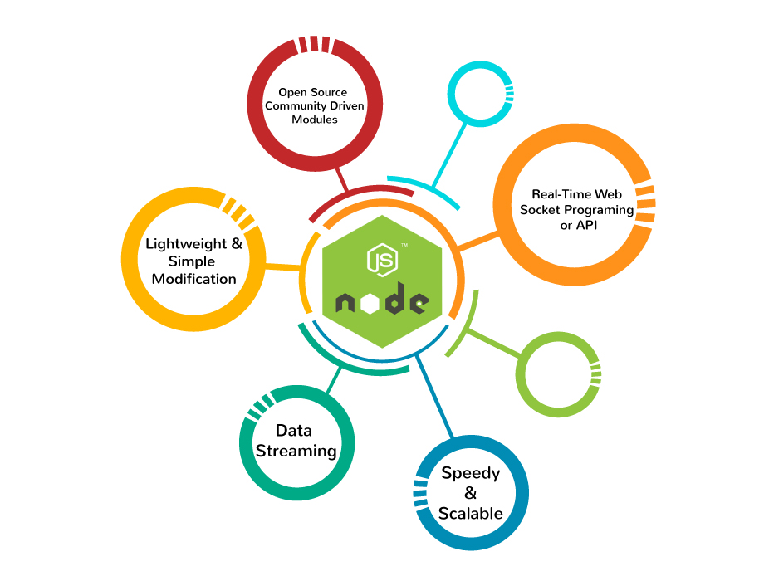

**Features of Node.js**

Following are some of the important features that make Node.js the first choice of software architects.

* Asynchronous and Event Driven − All APIs of Node.js library is asynchronous, that is, non-blocking. It essentially means a Node.js based server never waits for an API to return data. The server moves to the next API after calling it and a notification mechanism of Events of Node.js helps the server to get a response from the previous API call.
* Very Fast − Being built on Google Chrome's V8 JavaScript Engine, Node.js library is very fast in code execution.
* Single Threaded but Highly Scalable − Node.js uses a single threaded model with event looping. Event mechanism helps the server to respond in a non-blocking way and makes the server highly scalable as opposed to traditional servers which create limited threads to handle requests. Node.js uses a single threaded program and the same program can provide service to a much larger number of requests than traditional servers like Apache HTTP Server.
* No Buffering − Node.js applications never buffer any data. These applications simply output the data in chunks.
* License − Node.js is released under the MIT license.

**Who Uses Node.js?**

Following is the link on GitHub wiki containing an exhaustive list of projects, application and companies which are using Node.js. This list includes eBay, General Electric, GoDaddy, Microsoft, PayPal, Uber, Wikipins, Yahoo!, and Yammer to name a few.

* Projects, Applications, and Companies Using Node

**Concepts**

The following diagram depicts some important parts of Node.js which we will discuss in detail in the subsequent chapters.

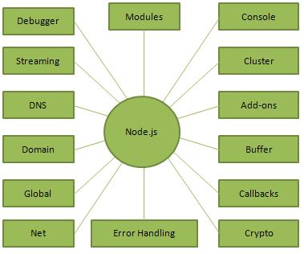

**Where to Use Node.js?**

Following are the areas where Node.js is proving itself as a perfect technology partner.

* I/O bound Applications
* Data Streaming Applications
* Data Intensive Real-time Applications (DIRT)
* JSON APIs based Applications
* Single Page Applications

**Where Not to Use Node.js?**

It is not advisable to use Node.js for CPU intensive applications.

**4.2 ReactJS**

React is a way to build user interfaces. It is only concerned with what you see on the front-end. React makes user interfaces very easy to build by cutting each page into pieces. We call these pieces components.

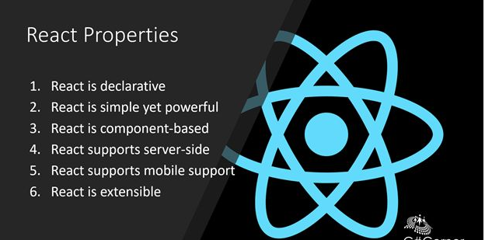

React’s popularity today has eclipsed that of all other front-end development frameworks. Here is why:

* Easy creation of dynamic applications: React makes it easier to create dynamic web applications because it requires less coding and offers more functionality, as opposed to JavaScript, where coding often gets complex very quickly.
* Improved performance: React uses Virtual DOM, thereby creating web applications faster. Virtual DOM compares the components’ previous states and updates only the items in the Real DOM that were changed, instead of updating all of the components again, as conventional web applications do.
* Reusable components: Components are the building blocks of any React application, and a single app usually consists of multiple components. These components have their logic and controls, and they can be reused throughout the application, which in turn dramatically reduces the application’s development time.
* Unidirectional data flow: React follows a unidirectional data flow. This means that when designing a React app, developers often nest child components within parent components. Since the data flows in a single direction, it becomes easier to debug errors and know where a problem occurs in an application at the moment in question.
* Small learning curve: React is easy to learn, as it mostly combines basic HTML and JavaScript concepts with some beneficial additions. Still, as is the case with other tools and frameworks, you have to spend some time to get a proper understanding of React’s library.
* It can be used for the development of both web and mobile apps: We already know that React is used for the development of web applications, but that’s not all it can do. There is a framework called React Native, derived from React itself, that is hugely popular and is used for creating beautiful mobile applications. So, in reality, React can be used for making both web and mobile applications.
* Dedicated tools for easy debugging: Facebook have released a Chrome extension that can be used to debug React applications. This makes the process of debugging React web applications faster and easier.
* The above reasons more than justify the popularity of the React library and why it is being adopted by a large number of organizations and businesses.

**4.2.1 Features**

* **JSX**

JSX is a JavaScript syntactic extension. It's a term used in React to describe how the user interface should seem. You can write HTML structures in the same file as JavaScript code by utilizing JSX.

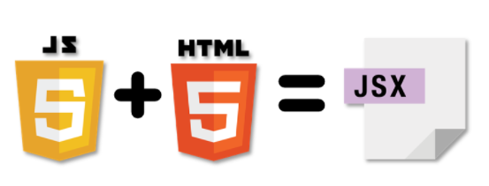

* **DOM**

The Virtual DOM is React's lightweight version of the Real DOM. Real DOM manipulation is substantially slower than virtual DOM manipulation. When an object's state changes, Virtual DOM updates only that object in the real DOM rather than all of them.

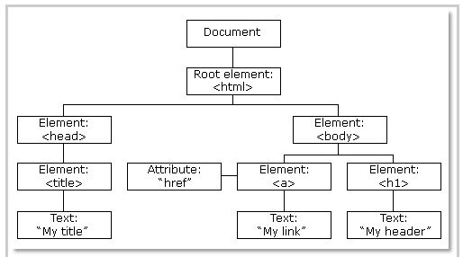

* **Components**

Components are the building blocks that comprise a React application representing a part of the user interface. Here in our deals page the various components can be as follows:

1. Header
2. Footer
3. Buttons
4. Product cards

* **Props**

Props, short for Properties in React Props, short for properties, allow the user to pass arguments or data to components. These props help make the components more dynamic. Props in a component are read-only and cannot be changed.

* **State**

A state is an object that stores properties values for those attributed to a component that could change over some time.

* **SetState**

A state can be updated to event handlers, server responses, or prop changes. This is done using setState method.

**4.3 JavaScript**

JavaScript (often shortened to JS) is a lightweight, interpreted, object-oriented language with first-class functions, and is best known as the scripting language for Web pages, but it's used in many non-browser environments as well. It is a prototype-based, multi-paradigm scripting language that is dynamic, and supports object-oriented, imperative, and functional programming styles.

There are many useful **JavaScript frameworks** and libraries available:

* Angular
* React
* jQuery
* Vue.js
* Ext.js
* Ember.js
* Meteor
* Mithril
* Node.js
* Polymer
* Aurelia
* Backbone.js

It is really impossible to give a complete list of all the available JavaScript frameworks and libraries. The JavaScript world is just too large and too much new is happening.

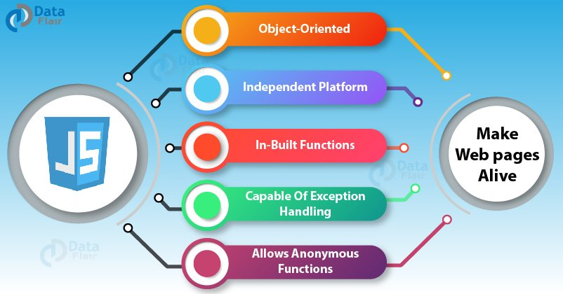

**Applications of JavaScript Programming**

As mentioned before, **JavaScript** is one of the most widely used **programming languages** (Front-end as well as Back-end). It has its presence in almost every area of software development. I'm going to list few of them here:

* **Client-side validation** - This is really important to verify any user input before submitting it to the server and JavaScript plays an important role in validating those inputs at front-end itself.
* **Manipulating HTML Pages** - JavaScript helps in manipulating HTML page on the fly. This helps in adding and deleting any HTML tag very easily using JavaScript and modify your HTML to change its look and feel based on different devices and requirements.
* **User Notifications** - You can use JavaScript to raise dynamic pop-ups on the webpages to give different types of notifications to your website visitors.
* **Back-end Data Loading** - JavaScript provides Ajax library which helps in loading back-end data while you are doing some other processing. This really gives an amazing experience to your website visitors.
* **Presentations** - JavaScript also provides the facility of creating presentations which gives website look and feel. JavaScript provides RevealJS and BespokeJS libraries to build a web-based slide presentation.
* **Server Applications** - Node JS is built on Chrome's JavaScript runtime for building fast and scalable network applications. This is an event-based library which helps in developing very sophisticated server applications including Web Servers.

**Advantages of JavaScript**

The merits of using JavaScript are −

* **Less server interaction** − You can validate user input before sending the page off to the server. This saves server traffic, which means less load on your server.
* **Immediate feedback to the visitors** − They don't have to wait for a page reload to see if they have forgotten to enter something.
* **Increased interactivity** − You can create interfaces that react when the user hovers over them with a mouse or activates them via the keyboard.
* **Richer interfaces** − You can use JavaScript to include such items as drag-and-drop components and sliders to give a Rich Interface to your site visitors.

**Limitations of JavaScript**

We cannot treat JavaScript as a full-fledged programming language. It lacks the following important features −

* Client-side JavaScript does not allow the reading or writing of files. This has been kept for security reason.
* JavaScript cannot be used for networking applications because there is no such support available.
* JavaScript doesn't have any multi-threading or multiprocessor capabilities.

**4.4 Cascading Style Sheets (CSS)**

Cascading Style Sheets, fondly referred to as CSS, is a simple design language intended to simplify the process of making web pages presentable.

CSS handles the look and feel part of a web page. Using CSS, you can control the color of the text, the style of fonts, the spacing between paragraphs, how columns are sized and laid out, what background images or colors are used, layout designs, variations in display for different devices and screen sizes as well as a variety of other effects.

CSS is easy to learn and understand but it provides powerful control over the presentation of an HTML document. Most commonly, CSS is combined with the markup languages HTML or XHTML.

There are 3 ways to write CSS in our HTML file.

* Inline CSS
* Internal CSS
* External CSS

**Advantages of CSS**

* **CSS saves time** − You can write CSS once and then reuse same sheet in multiple HTML pages. You can define a style for each HTML element and apply it to as many Web pages as you want.
* **Pages load faster** − If you are using CSS, you do not need to write HTML tag attributes every time. Just write one CSS rule of a tag and apply it to all the occurrences of that tag. So, less code means faster download times.
* **Easy maintenance** − To make a global change, simply change the style, and all elements in all the web pages will be updated automatically.
* **Superior styles to HTM**L − CSS have a much wider array of attributes than HTML, so you can give a far better look to your HTML page in comparison to HTML attributes.
* **Multiple Device Compatibility** − Style sheets allow content to be optimized for more than one type of device. By using the same HTML document, different versions of a website can be presented for handheld devices such as PDAs and cell phones or for printing.
* **Global web standards** − Now HTML attributes are being deprecated and it is being recommended to use CSS. So, it is a good idea to start using CSS in all the HTML pages to make them compatible to future browsers.

**4.5 Git**

Git is software for tracking changes in any set of files, usually used for coordinating work among programmers collaboratively developing source code during software development. Its goals include speed, data integrity, and support for distributed, non-linear workflows.

The Git feature that really makes it stand apart from nearly every other SCM out there is its branching model.

Git allows and encourages you to have multiple local branches that can be entirely independent of each other. The creation, merging, and deletion of those lines of development takes seconds.

This means that you can do things like:

* **Frictionless Context Switching**. Create a branch to try out an idea, commit a few times, switch back to where you branched from, apply a patch, switch back to where you are experimenting, and merge it in.
* **Role-Based Codelines**. Have a branch that always contains only what goes to production, another that you merge work into for testing, and several smaller ones for day-to-day work.
* **Feature Based Workflow**. Create new branches for each new feature you're working on so you can seamlessly switch back and forth between them, then delete each branch when that feature gets merged into your main line.
* **Disposable Experimentation**. Create a branch to experiment in, realize it's not going to work, and just delete it - abandoning the work—with nobody else ever seeing it (even if you've pushed other branches in the meantime).

**Chapter-5**

* 1. **Use-Case Diagram**

Use case diagram represents the interactions of the system administrator, bet creator and the participants to this system, it is a graphical depiction of the user’s possible interactions with the system.

Below diagram shows the use-case diagram of an e commerce website.

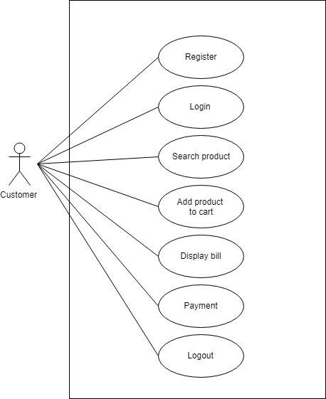

* 1. **State Chart Diagram**

State chart diagram describes the flow of control from one state to another state.

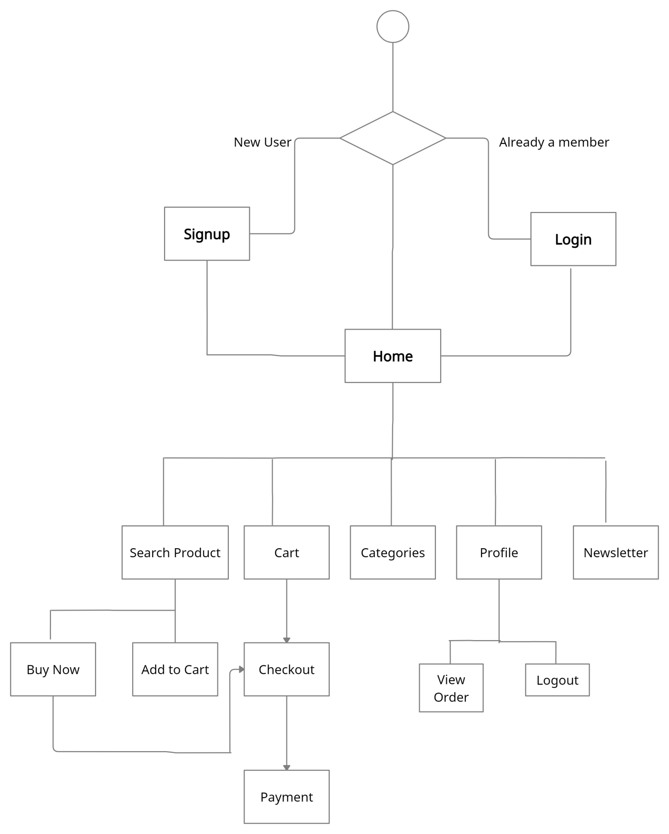

**Chapter-6**

**6.1 Login Page**

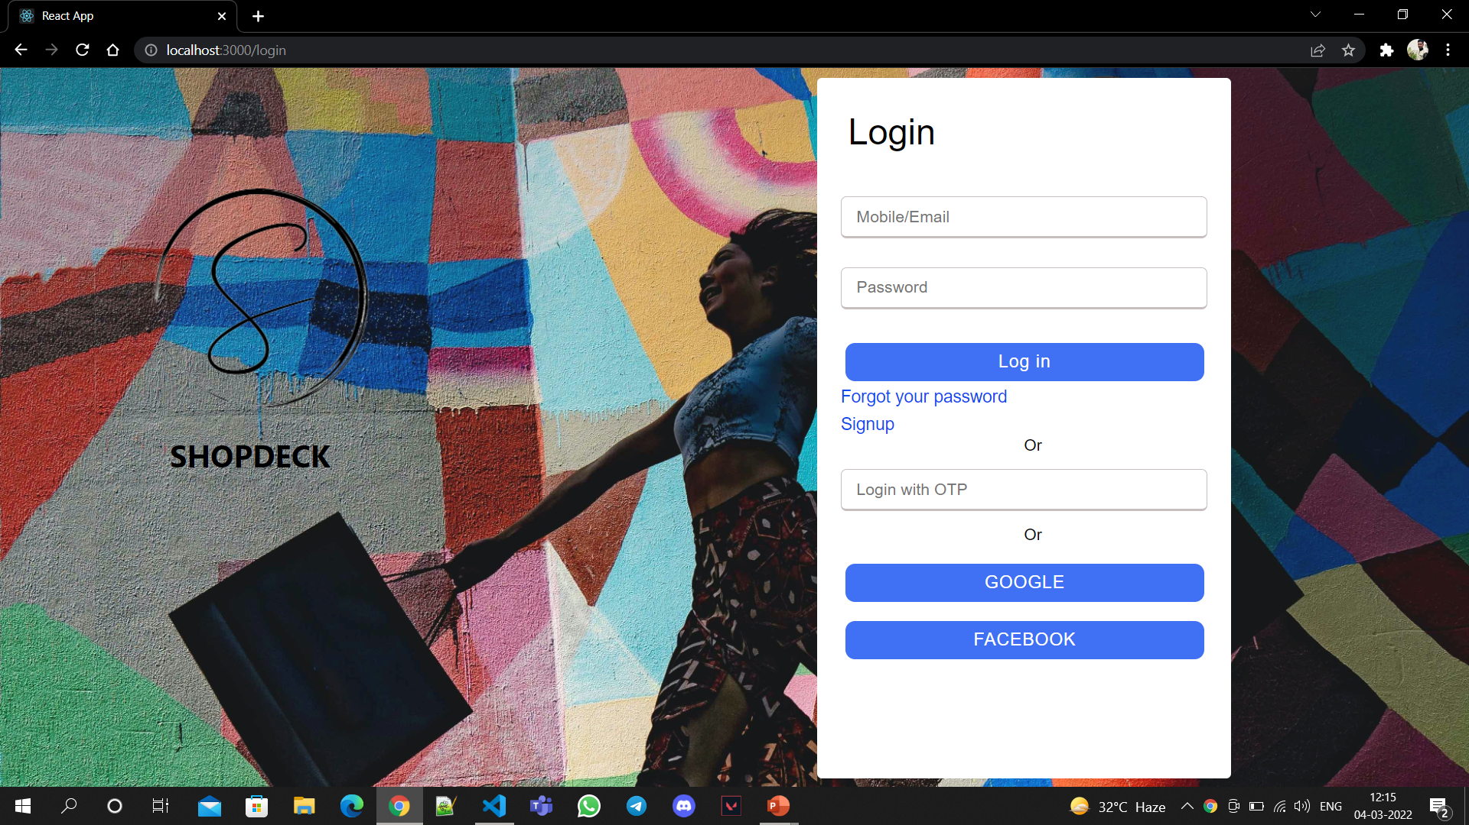

A login page is where the user will enter its credential in order to access the features like placing order and making purchase for the product.

There are various login methods to validate authorization namely, via username and password, via OTP, or via Google or Facebook validation.

Components used to create this page are forms which is later also used in other pages which will be described below.

Since there is no back-end in the project, therefore only navigation is done and a database can be added for the validation process.

**6.2 Sign-Up Page**

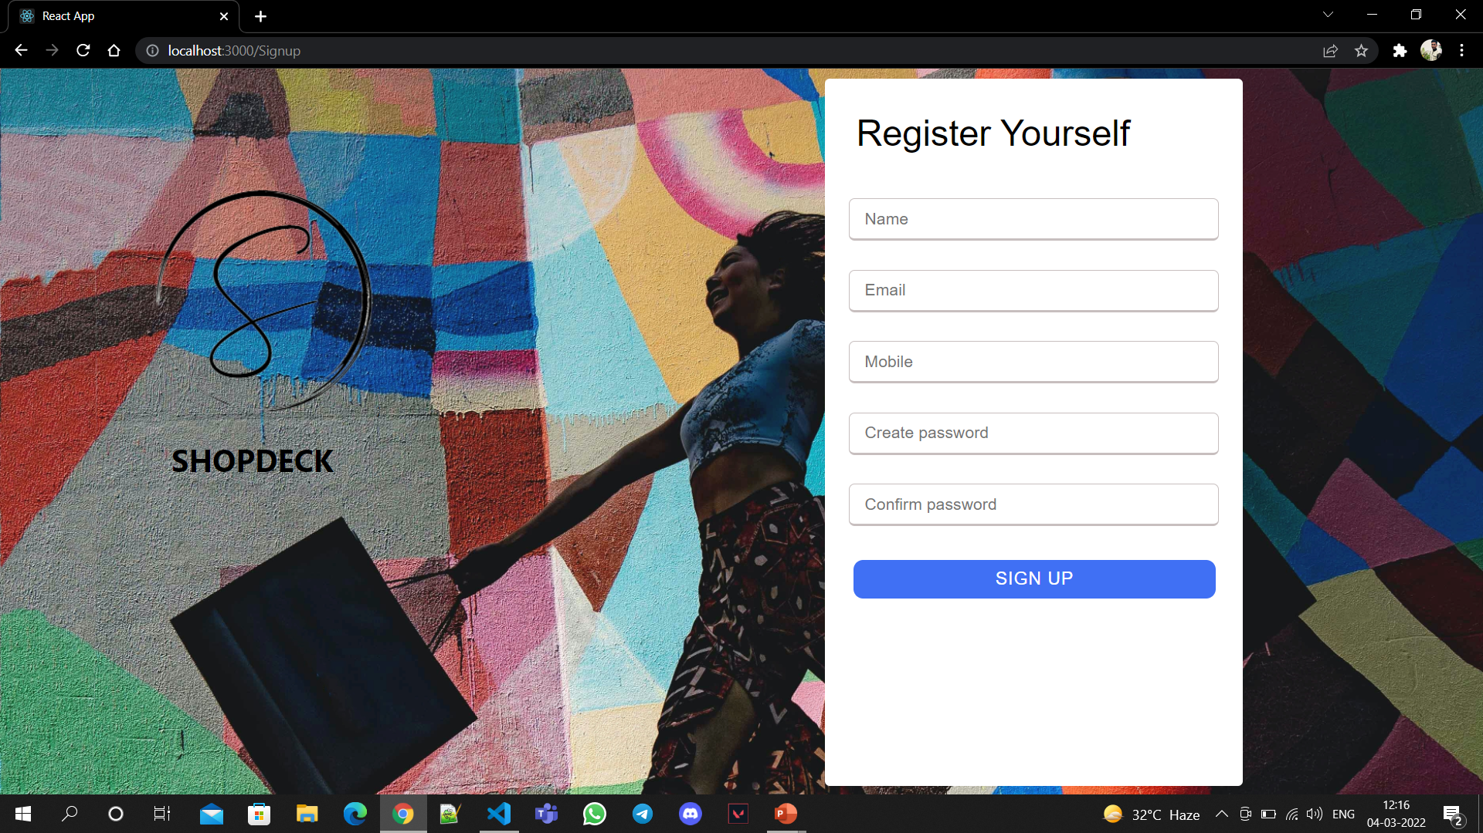

A Sign-up is used to create the accounts for new users where a user will need to provide the necessary details in order to create the account.

The components used to create this page are same as the one used in Login page i.e., a form.

**6.3 Home Page**

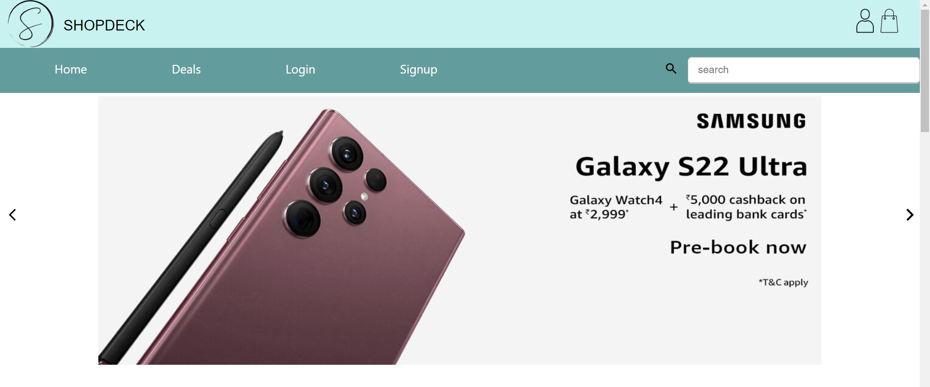

This is the first interactive page for a user when he launches the website.

The components used in this page are:

* Navbar: A header which contains website logo, name, pages (home, deals etc.) and search-bar.
* Footer: It contains the various links such as about, contacts, customer service etc.
* Slider: First interactive which shows new products or deals on banner.
* Categories: Shows different product categories.
* Products: Shows different products.
* Newsletter

**6.4 Home Page Categories**



This is the second part of the home page where some categories are mentioned.

The components used in this page are:

* Navbar: A header which contains website logo, name, pages (home, deals etc.) and search-bar.
* Footer: It contains the various links such as about, contacts, customer service etc.
* Slider: First interactive which shows new products or deals on banner.
* Categories: Shows different product categories.
* Products: Shows different products.
* Newsletter

**6.5 Product Details**

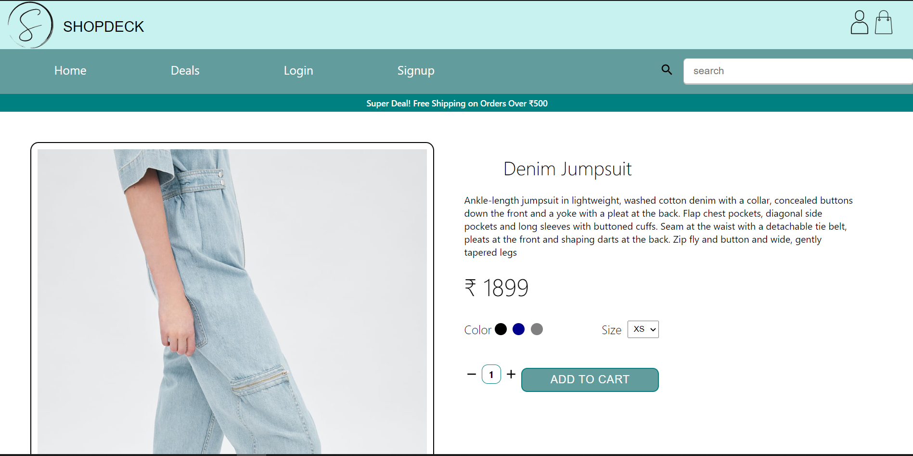

This page contains the details of the product where its description, price, and other options are available (add to cart, rating, reviews etc.)

The components used in this page are:

* Navbar: A header which contains website logo, name, pages (home, deals etc.) and search-bar.
* Footer: It contains the various links such as about, contacts, customer service etc.
* Newsletter
* Announcement

**6.6 Catalog**

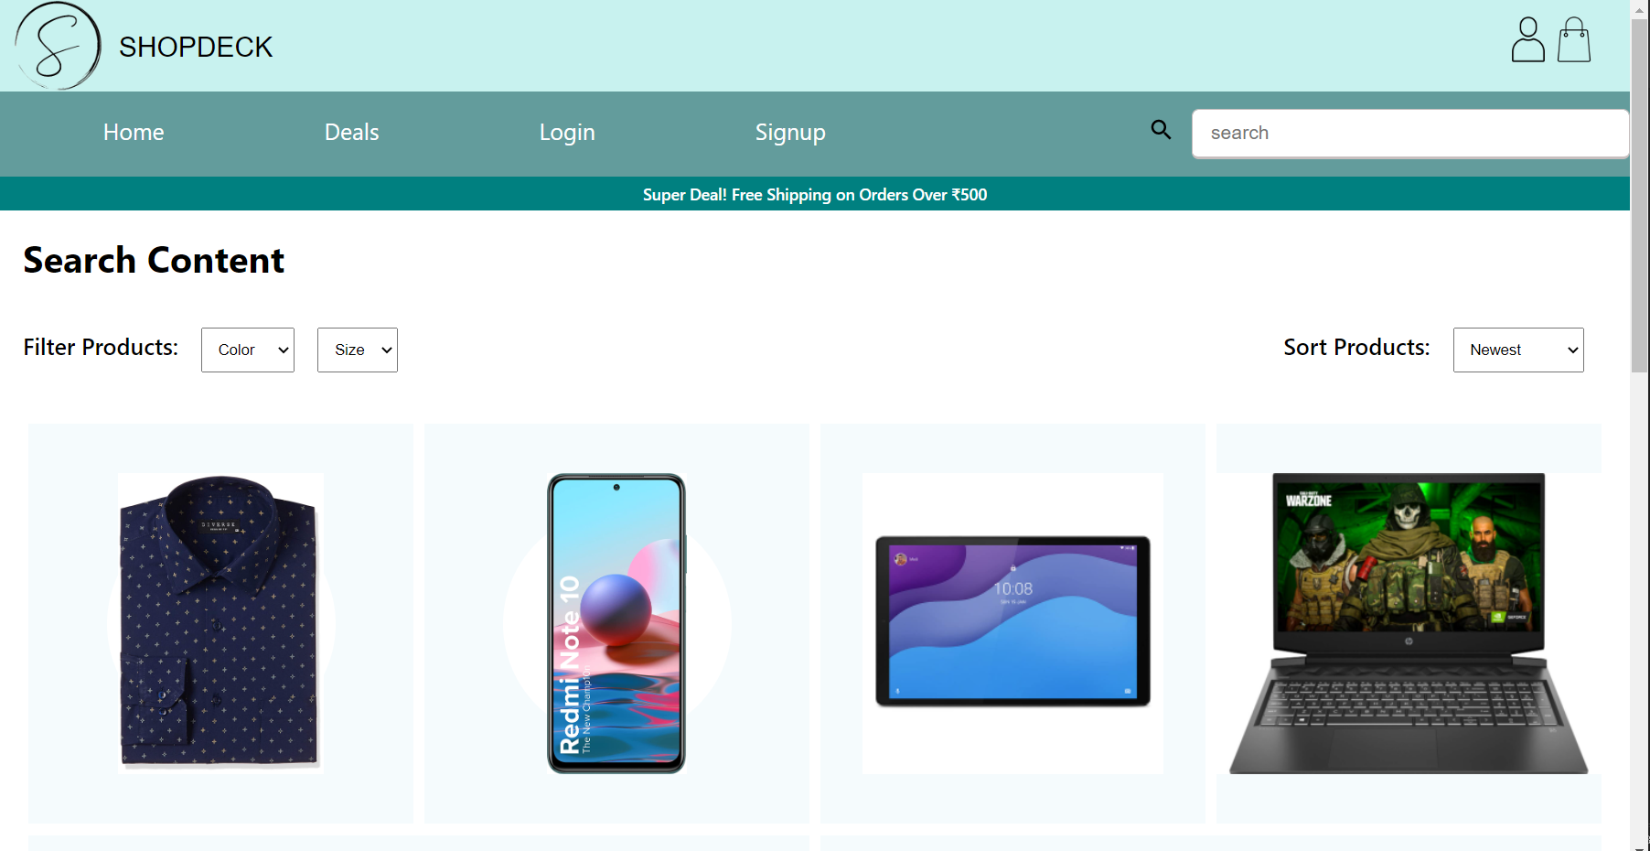

This page contains various products according to the category with some filter options.

The components used in this page are:

* Navbar: A header which contains website logo, name, pages (home, deals etc.) and search-bar.
* Footer: It contains the various links such as about, contacts, customer service etc.
* Newsletter
* Announcement

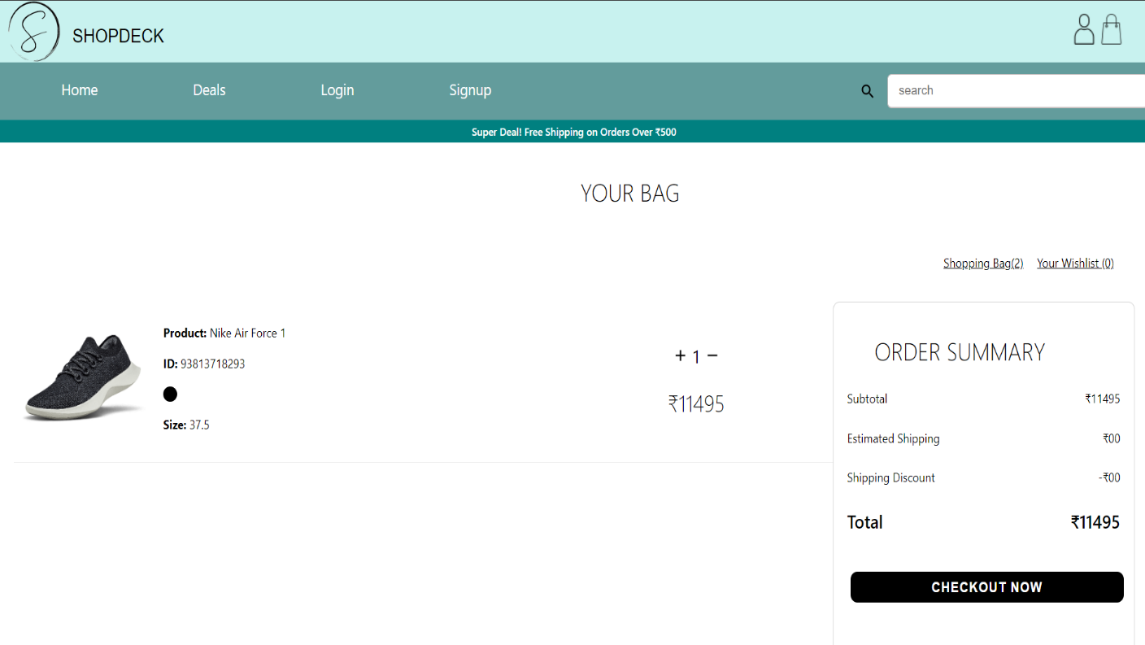**6.6 Cart**

After adding the product to cart, this page provides to review the products and proceed to make purchase and navigate to checkout.

The components used in this page are:

* Navbar: A header which contains website logo, name, pages (home, deals etc.) and search-bar.
* Footer: It contains the various links such as about, contacts, customer service etc.
* Newsletter
* Announcement

**6.7 Payment Page**

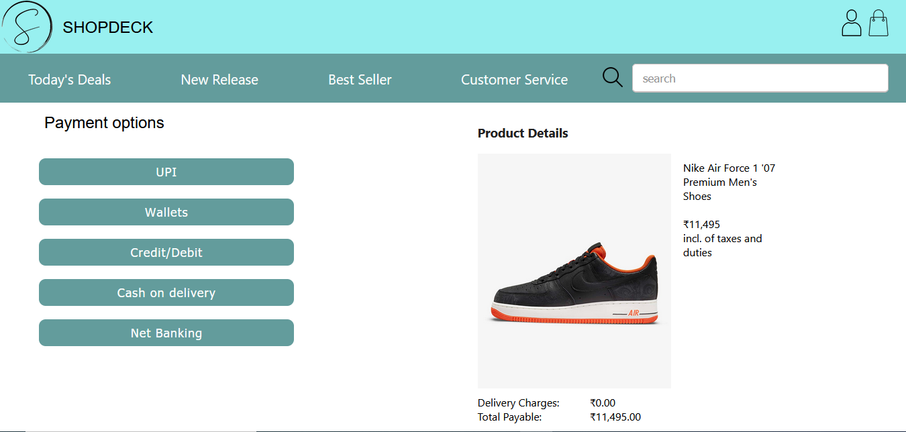

Payment page provide user various option to make the payment and proceed to place the order for the user.

The components used in this page are:

* Navbar: A header which contains website logo, name, pages (home, deals etc.) and search-bar.

**6.8 Checkout Page**

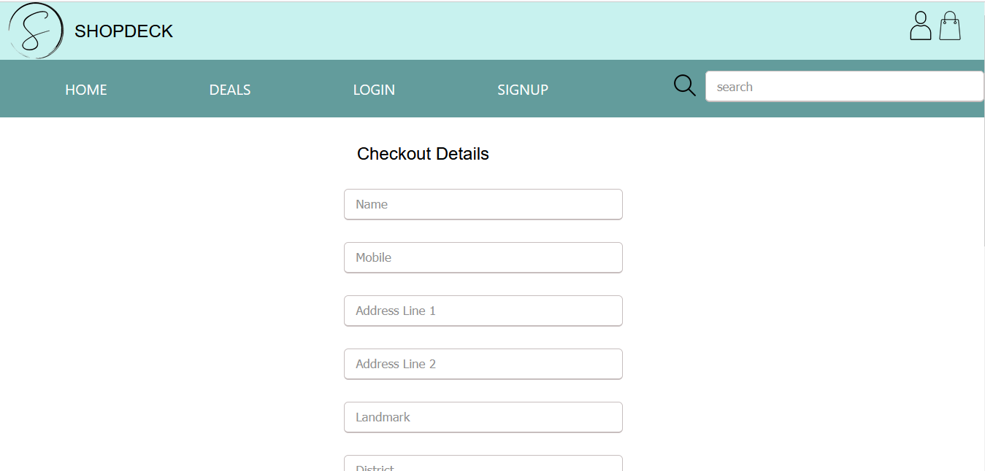

In Checkout page, user provide the personal details to deliver the product he purchased.

The components used in this page are:

* Navbar: A header which contains website logo, name, pages (home, deals etc.) and search-bar.
* Footer: It contains the various links such as about, contacts, customer service etc.

**Chapter-7**

**Result and Discussion**

ShopDeck was a project allotted to our team at Tata Consultancy Services as a part of our internship at the organization that aimed at improving our proficiency in various market capturing technologies such as ReactJS, Firebase, NodeJS, Git, etc. and to practice various software development practices while developing our project. In the tenure between 13-Jan-2022 to 22-Apr-2022 we learned the technologies that were required to develop the target application and then developed the ShopDeck in the supervision of Mr. Amir Sohel.

The project was built with an aim to ease to improve the user experience of online shopping and automizing the process of the shopping. Any interested audience can access our Web Application for checking out/ viewing different categories of products along with its details, but to add it to cart or to buy the product one must Sign In if he/she is a registered customer or Register as a new user to our application. The interested buyer is also assisted with a payment gateway where he can choose his/her option of payment and also specify the delivery details. The application was thoroughly checked by our supervisor and did meet the targeted goals that were part of our internship.

This project helped me in understanding company’s work environment and market current technologies. I also became proficient with the languages and various software that I used during the development of the application. It was a great experience over all.

**Chapter-8**

**Summary and Conclusion**

There was a plethora of factors that contributed to my enjoyable internship experience with Tata Consultancy Services. Under the leadership and guidance of my amazing mentors, I was exposed to many opportunities and learnt from the best. On a more personal level, my mentors really cared for me. They ensured that I got some time to rest after tough periods at work. My mentors played an important role during my internship stint at Tata Consultancy Services. Also, I enjoyed working in an environment that provided you with almost everything. I realized that one should never be afraid to ask. When you ask, then you will learn more and improve yourself there and then.

Tata Consultancy Services has given me one of the biggest takeaways and has taught me various important lessons. Also, I had the opportunity to practice the art of being detailed and meticulous. I am better prepared for working life in the near future.

**Chapter-9**

**Future Scope**

The current project is sufficient in fulfilling the requirements given the organization to design and show the basic features of an e-Commerce website, but it is only based on the front-end design only and other functionalities can be added such as:

* Back-end: A database can be added to store the data of the user and products which can be accessed via an APN.
* Security: Security measures can be added like username – password authentication, OTP authentication and other measures to ensure the safety of the data of a user.
* Portal: A payment portal can be added for placing an order.
* Administrator access: An administrator access can be added to manage the web application and its data.
* Further addition of different type of users can be added such as buyer, seller.

**Bibliography**

[1] <https://reactjs.org/docs/getting-started.html>

[2] <https://www.geeksforgeeks.org/javascript/>

[3] <https://www.javascript.com/learn/strings>

[4] <https://code.visualstudio.com/docs>

[5] <https://firebase.google.com/docs/firestore>